

Programing Fundamental

Lab 4 Assignment

Session: 1E

Name:

Sabir Hussain

Roll no:

BCSM-f19-262

Pro: Hafiz Muhammad Zahid

Problem set 1

1. Write a C++ program to print all-natural numbers from 1 to n.

**Program:**

#include<iostream>

#include<conio.h>

using namespace std;

int main ()

{

int n, i=1;

cout<<"Enter nth term of Natural number = ";

cin>>n;

while(i<=n)

{

cout<<i<<"\t";

i++;

}

getch ();

return 0;

}

**Output console:**

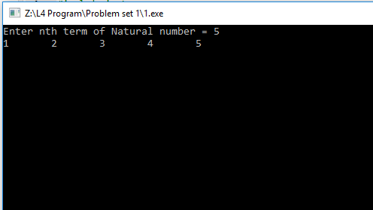

1. Write a C++ program to print all-natural numbers in reverse (from n to 1).

**Program:**

**#include<iostream>**

**#include<conio.h>**

**using namespace std;**

**int main ()**

**{**

**int n, i=1;**

**cout<<"Enter nth term of Natural number = ";**

**cin>>n;**

**while(n>=i)**

**{**

**cout<<n<<"\t";**

**n--;**

**}**

**getch ();**

**return 0;**

**}**

**Output console:**

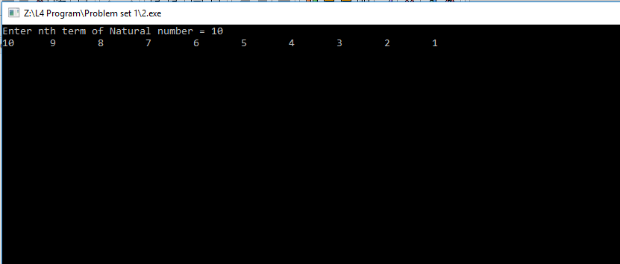

3.Write a C ++ program to print all alphabets from a to z.

**Program:**

**#include<iostream>**

**#include<conio.h>**

**using namespace std;**

**int main()**

**{**

**char f,l;**

**cout<<"Enter starting alphabet = ";**

**cin>>f;**

**cout<<"Enter Last alphabet = ";**

**cin>>l;**

**while(f<=l)**

**{**

**cout<<f<<"\t";**

**f++;**

**}**

**getch();**

**return 0;**

**}**

**Output console:**

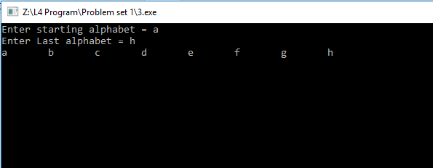

1. **Write a C++ program to print all even numbers between 1 to 100.**

**Program:**

**#include<iostream>**

**#include<conio.h>**

**using namespace std;**

**int main ()**

**{**

**int i=1;**

**cout<<"All Even number from 1 to 100 "<<endl<<endl;**

**while (i <=100)**

**{**

**if(i%2==0)**

**{**

**cout<<i<<"\t";**

**}**

**i++;**

**}**

**getch ();**

**return 0;**

**}**

**Output console:**

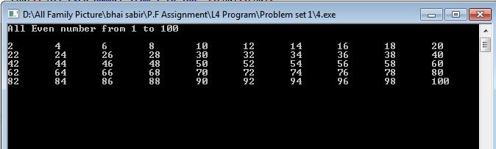

**5. Write a C++ program to print all odd number between 1 to 100.**

**Program:**

#include<iostream>

#include<conio.h>

using namespace std;

int main ()

{

int i=1;

cout<<"All Even number from 1 to 100 "<<endl<<endl;

while(i<=100)

{

if(i%2==1)

{

cout<<i<<"\t";

}

i++;

}

getch ();

return 0;

**Output console:**

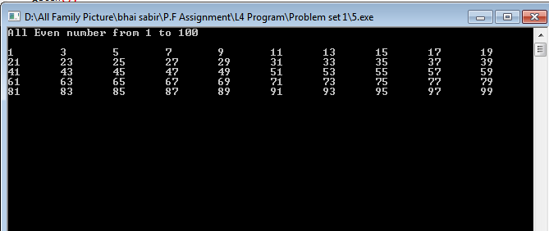

}

1. **Write a C++ program to find sum of all-natural numbers between 1 to n.**

**Program:**

**#include<iostream>**

**#include<conio.h>**

**using namespace std;**

**int main ()**

**{**

**int n1, i=1, sum=0;**

**cout<<"Enter any Number = ";**

**cin>>n1;**

**while(i<=n1)**

**{**

**sum=sum+i;**

**i++;**

**}**

**cout<<"Sum of numbers up to "<<n1<<" = "<<sum;**

**getch ();**

**return 0;**

**}**

**Output console:**

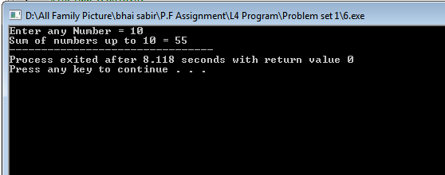

**7. Write a C++ program to find sum of all even numbers between 1 to n.**

**Program:**

**#include<iostream>**

**#include<conio.h>**

**using namespace std;**

**int main ()**

**{**

**int n1, i=2, sum=0;**

**cout<<"Enter any Number = ";**

**cin>>n1;**

**while(i<=n1)**

**{**

**if(i%2==0)**

**{**

**sum=sum+i;**

**}**

**i++;**

**}**

**cout<<"Sum of Even numbers up to "<<n1<<" = "<<sum;**

**getch ();**

**return 0;**

**}**

**Output console:**

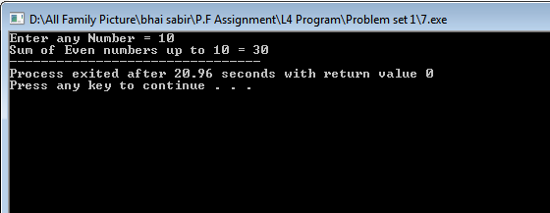

**Problem set 2**

**1.** **Write a C+ program to find sum of all odd numbers between 1 to n.**

**Program:**

**#include<iostream>**

**#include<conio.h>**

**using namespace std;**

**int main ()**

**{**

**int n1, i=1, sum=0;**

**cout<<"Enter any Number = ";**

**cin>>n1;**

**while(i<=n1)**

**{**

**if(i%2==1)**

**{**

**sum=sum+i;**

**}**

**i++;**

**}**

**cout<<"Sum of Odd numbers up to "<<n1<<" = "<<sum;**

**getch ();**

**return 0;**

**}**

**Output console:**

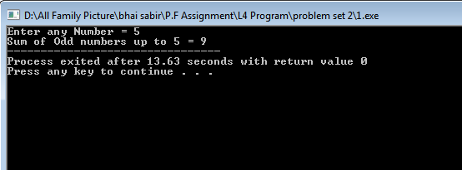

**2. Write a C++ program to print multiplication table of any number.**

**Program:**

**#include<iostream>**

**#include<conio.h>**

**using namespace std;**

**int main ()**

**{**

**int n1, i=1;**

**cout<<"Enter any Table Number = ";**

**cin>>n1;**

**while(i<=10)**

**{**

**cout<<n1<<" * "<<i<<" = "<<n1*i<<endl;**

**i++;**

**}**

**getch ();**

**return 0;**

**}**

**Output console:** 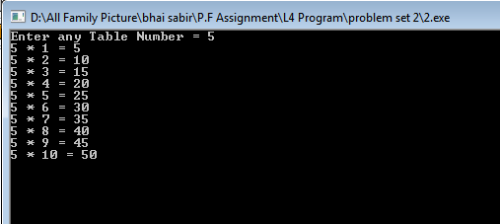

**3. Write a C++ program to count number of digits in a number.**

**Program:**

**#include<iostream>**

**#include<conio.h>**

**using namespace std;**

**int main ()**

**{**

**int n1, n, l=0;**

**cout<<"Enter any number = ";**

**cin>>n1;**

**n=n1;**

**while (n1! =0)**

**{**

**n1=n1/10;**

**l++;**

**}**

**cout<<"Digits in "<<n<<" = "<<l;**

**getch ();**

**return 0;**

**}**

**Output console:**

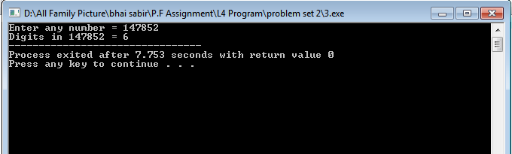

**4. Write a C++ program to find first and last digit of a number.**

**Program:**

**#include<iostream>**

**#include<conio.h>**

**using namespace std;**

**int main ()**

**{**

**int n1, l, sum;**

**cout<<"Enter any number = ";**

**cin>>n1;**

**l=n1%10;**

**while(n1>9)**

**{**

**n1=n1/10;**

**}**

**cout<<"First Number is "<<n1<<endl;**

**cout<<"Last Number is "<<l<<endl;**

**getch ();**

**return 0;**

**}**

**Output console:**

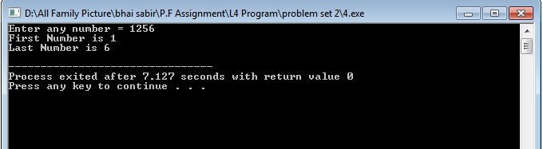

1. **Write a C++ program to find sum of first and last digit of a number.**

**Program:**

**#include<iostream>**

**#include<conio.h>**

**using namespace std;**

**int main ()**

**{**

**int n1, l, sum;**

**cout<<"Enter any number = ";**

**cin>>n1;**

**l=n1%10;**

**while(n1>9)**

**{**

**n1=n1/10;**

**}**

**cout<<"First Number is "<<n1<<endl;**

**cout<<"Last Number is "<<l<<endl;**

**sum=l+n1;**

**cout<<"Sum of First & Last Number = "<<sum;**

**getch ();**

**return 0;**

**}**

**Output console:**

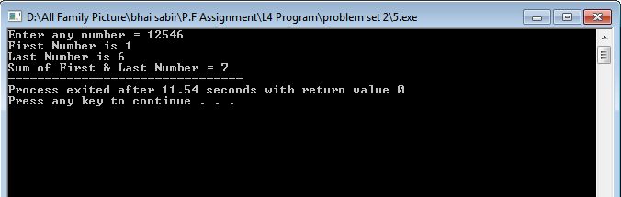

**6. Write a C++ program to swap first and last digits of a number.**

**Program:**

**#include<iostream>**

**#include<conio.h>**

**using namespace std;**

**int main ()**

**{**

**int n, l, f, s, fn;**

**cout<<"Enter any Number = ";**

**cin>>n;**

**l=n%10;**

**while(n>9)**

**{**

**n=n/10;**

**}**

**f=n;**

**cout<<"First Number = "<<f<<endl;**

**cout<<"Last Number = "<<l<<endl;**

**cout<<endl<<"After Swaping Number "<<endl<<endl;**

**s=f;**

**f=l;**

**l=s;**

**cout<<"First Number = "<<f<<endl;**

**cout<<"Last Number = "<<l<<endl;**

**getch ();**

**return 0;**

**}**

**Output console:**

